

**ALAGAPPA COLLEGE OF TECHNOLOGY**

**ANNA UNIVERSITY-600025**

**NM Assignment - Digital Marketing**

**Name:** Jesolin D

**Roll No:** 2020308018

**Department:** B. Tech Pharmaceutical Technology

**College:** Alagappa College of Technology, Anna University.

**Naan Mudhalavan ID:** 660C044CA6371098EA744F9D2E8E5E9B

**Zone:** Zone-1

**1. Create a blog or website using Blogpost Customize the theme design and post new article with 500 words.**

<https://jesolin.blogspot.com/2023/08/brownie.html?m=1>

**2. Create a New Facebook Business Page and post one social media poster for your brand.**

<https://m.facebook.com/story.php?story_fbid=pfbid0ZmaLNc6DzeGCGe5iZoiJRTi32Khpvwj3puM7v7oeZBRAszf5Ep4P71ifSVUvAvAYl&id=61550756489253&mibextid=Nif5oz>

Company Name : Elo Musicals

Company Type : Education

Logo:

**3. Create and design a social media advertisement poster using canva.**

**4. Create email newsletter design using MailChimp or canva tool.**

Google Analytics ID : G-XZKW18LS06

Email Newsletter link : <https://jesolin.blogspot.com/2023/09/blog-post.html>

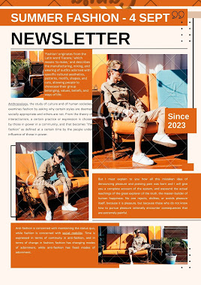

**5) Create linkedin profile.**

<https://www.linkedin.com/in/jesolin-d-907a8b1b0>